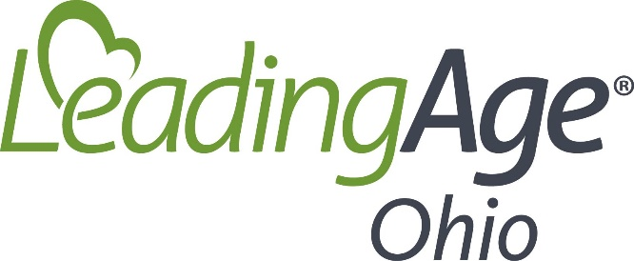

Authorization Form – LeadingAge National Member Survey

To Whom It May Concern,

By my signature below, I authorize LeadingAge to release the data provided for the LeadingAge Member Survey to Dr. Allan Parnell (University of North Carolina) for LeadingAge Ohio’s Economic Impact Study. The data may not be utilized for any other purpose.

Printed Name:

Signature:

Date:

