Short Stay and Long Stay Pain QM
This measure captures the percent of residents, with at least one episode of moderate/severe pain or horrible/excruciating pain of any frequency, in the last 5 days.

Key Points!
For both Short Stay and Long Stay-
- This QM only captures self-reported pain. This means, only the Pain Assessment Interview is capable of triggering the measure. The Staff Assessment for Pain has no impact on this QM.
- Only the Target Assessment is used. The Target Assessment is the most recent assessment in the target period (i.e. a calendar quarter).

What MDS Items Trigger the Pain QM?
For both Short Stay and Long Stay-
- The pain QM will trigger for residents whose Target Assessment meets either or both of the following conditions:
  - Condition #1: Resident reports almost constant or frequent pain with a Numeric Rating of 5-9 or Verbal Descriptor of Moderate or Severe.
  - Condition #2: Resident reports very severe/horrible pain of any frequency.
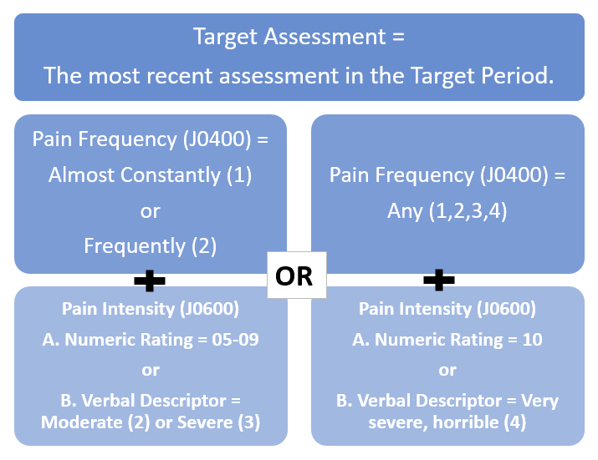

Tips for Success!
- Assess pain on day 1-2 of stay. If pain is present, get interventions in place early to allow time for optimal pain control before the pain interview has to be conducted.
  - Complete a thorough assessment. Can the cause of pain be eliminated or reduced?
  - Obtain pain history from the resident/resident representative. How has the pain progressed? What makes it worse? What makes it better? Implement interventions that have proven to be effective for managing the resident’s pain in the past.
  - Consult with the physician about getting routine analgesic orders and PRN orders for breakthrough pain, as appropriate.
  - Administer pain interventions before and after therapy.
- Change the perception of pain rating in your facility. Let residents know that you want to keep their pain level at 4 or below. Make sure your nurses and physicians are aware of this goal and that you expect interventions to be provided BEFORE pain intensity exceeds a level 4.
- Interview timing can be important. Don’t interview a resident with arthritis in the early morning as joint stiffness is more likely in the morning. Don’t interview residents right after therapy when pain is likely the most significant.
- Remember only the target assessment is used (the last assessment in the quarter). If the resident triggered on the most recent MDS, but now pain is controlled, you can complete a new MDS to stop that resident from triggering for pain.
- The sample (denominator count) is all residents with Completed Interviews-
  - Are you interviewing all residents that are at least sometimes understood?
    - Don’t automatically exclude cognitively impaired residents from the pain interview by answering ‘No’ to the gateway question (“Should Pain Assessment Interview be conducted?”).
    - Pain is very subjective! Most residents are capable of answering yes/no questions- so give EVERY resident the opportunity to answer!
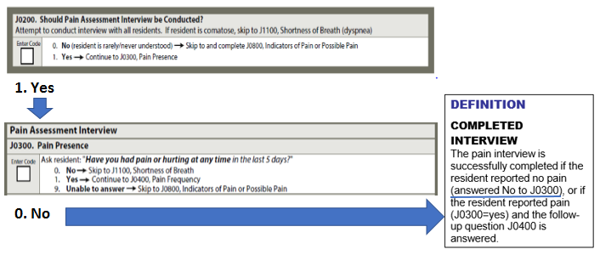

Each ‘No’ response to the Pain Presence question increases the sample size (denominator). The more “no” responses you get, the lower your Pain QM percentage will be!
- Example:
• 10 residents report moderate to severe pain (numerator/triggering residents)
• 40 residents complete the interview (denominator). 10/40= 25%
• Vs. 80 residents complete the interview (denominator) 10/80= 13%

QAPI
Quality Measures cannot rest solely on the shoulders of the MDS nurse! Take a team approach! Make pain management a focus of your facility’s Quality Assurance Performance Improvement program! You already have the data……how can you work together to improve it?!

