Percent of Residents Who Newly Received an Antipsychotic Medication (Short Stay)

This measure reports the percentage of short stay residents who are receiving an antipsychotic medication during the target period, but not on their initial assessment.

Key Points!
- The Short Stay Antipsychotic measure is triggered somewhat differently than the Long Stay Antipsychotic measure.
- This measure uses a look-back scan, so NOT only the Target Assessment (most recent) is used. Look-back scan means all assessments within the current episode are scanned for the triggering item.

What MDS Item Triggers the Short Stay Antipsychotic Measure?
- In simple terms, the Short Stay Antipsychotic measure triggers when:
  - The initial assessment does not include antipsychotics (N0410A=0), and
  - Any subsequent assessment does include antipsychotics (N0410A=1-7)
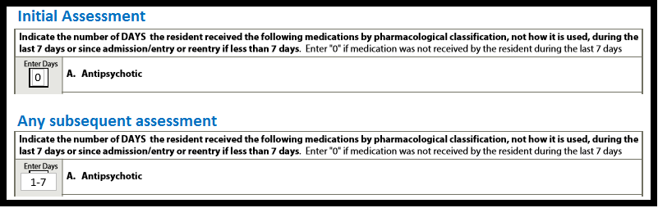
- Note: the initial assessment is defined as the first assessment following the admission entry record at the beginning of the resident’s selected episode. The initial assessment could be an Admission, PPS 5 day, or OBRA discharge, whichever is completed FIRST after the admission entry record.

But wait…there are some EXCLUSIONS!!
Even if a resident newly receives antipsychotic medications, they will not trigger the measure if any of the following related conditions are present on any assessment in a look-back scan:
- Schizophrenia (I6000 = [1]).
- Tourette’s syndrome (I5350 = [1]).
- Huntington’s disease (I5250 = [1]).
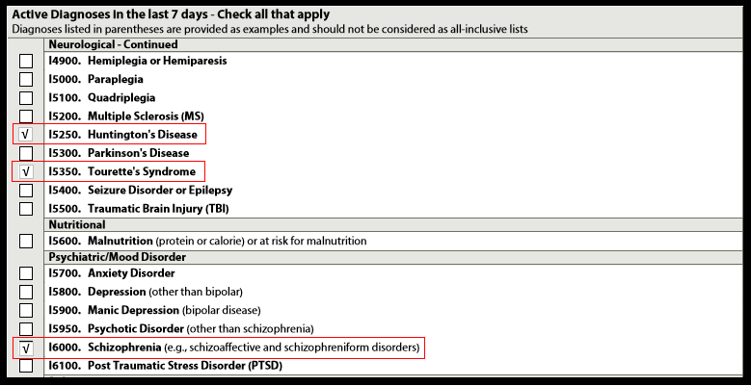

Tips for Success!
- Ensure the initial assessment is coded accurately!! If the resident was admitted with or started an antipsychotic prior to the ARD of the initial assessment, make sure it is coded!
  - Remember, in some cases the initial assessment may be a discharge return anticipated. NACs often rush through discharge assessments, especially when not much information is known due to really short stays, but they need to make sure antipsychotics are coded if they were present in the observation period.
- Educate your nurses! If residents exhibit new behaviors, discourage initiating antipsychotics before attempting to identify the root cause.
  - Use the CAA resources in Appendix C of the RAI User’s Manual to help find the root cause. Is the resident experiencing pain or getting an infection?
  - Attempt non-pharmacological interventions first and evaluate effectiveness.
- Complete a medication reconciliation with residents/resident representatives upon admission. If residents have been taking antipsychotics for years, but they were inadvertently left off the transfer orders, contact the physician about getting them reinitiated prior to the initial assessment, if appropriate.
- Discuss with the DON and nursing supervisors the facility process related to direct care nurses notifying supervisors of a resident’s change in behavior to ensure support to direct care staff, assessment, and interventions prior to medication request.
- Discuss antipsychotic orders with the physician. Determine if the resident has an exclusionary diagnosis that needs to be added to his/her profile.

