Percent of Residents Who Received an Antipsychotic Medication (Long-Stay)

This measure reports the percentage of long-stay residents who are receiving antipsychotic drugs in the target period.

Key Points!
- The Long-Stay Antipsychotic measure is triggered somewhat differently than the Short-Stay Antipsychotic measure.
- For the Long-Stay measure, only the Target Assessment is used. The Target Assessment is the most recent assessment in the target period (i.e. a calendar quarter).

What MDS Item Triggers the Long-Stay Antipsychotic Measure?
- Long-stay residents will trigger this QM when their target assessment includes 1-7 days of antipsychotics:
  - N0410A = [1, 2, 3, 4, 5, 6, 7]
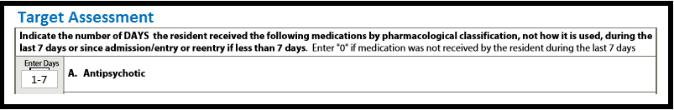
This measure has some EXCLUSIONS!!
Even if a long-stay resident received antipsychotic medications, they will not trigger the measure if any of the following related conditions are present on the MDS:
- Schizophrenia (I6000 = [1]).
- Tourette’s syndrome (I5350 = [1]).
- Huntington’s disease (I5250 = [1]).

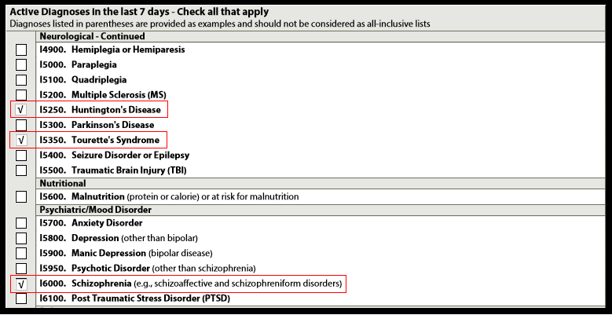

Tips for Success!
- Educate your nurses! If residents exhibit new behaviors, discourage initiating antipsychotics before attempting to identify the root cause.
  - Use the CAA resources in Appendix C of the RAI User’s Manual to help find the root cause. Is the resident experiencing pain or getting an infection?
  - Attempt non-pharmacological interventions first and evaluate effectiveness.
- Discuss with the DON and nursing supervisors the facility process related to direct care nurses notifying supervisors of a resident’s change in behavior to ensure support to direct care staff, assessment, and interventions prior to medication request.
- Discuss antipsychotic orders with the physician. Determine if the resident has an exclusionary diagnosis that needs to be added to his/her profile.
- Coordinate and discuss recommendations for Gradual Dose Reductions (GDR) with your pharmacist. Ensure pharmacy recommendations are promptly communicated to the physician.
- Identify residents on your Resident Level QM report who are triggering. If their antipsychotic has been discontinued since their last MDS, consider completing a new MDS (a new Target Assessment, where N0410A will equal zero).

