Percent of Residents Who Have/Had a Catheter Inserted and Left in Their Bladder (Long Stay)

This measure reports the percentage of residents who have had an indwelling catheter in the last 7 days.

Key Points!
- For this measure, only the Target Assessment is used. The Target Assessment is the most recent assessment in the target period (i.e. a calendar quarter).
What MDS Item Triggers the Long-Stay Catheter Measure?
- Long-stay residents will trigger this QM when their target assessment indicates the use of an indwelling catheter
  - H0100A = [1]
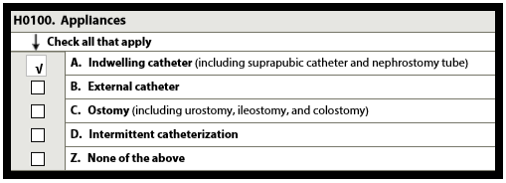
This measure has some EXCLUSIONS!!
If the target assessment is an admission assessment (A0310A = [01]) or a PPS 5-day (A0310B = [01]), it is excluded and will not trigger this QM.
Even if a long-stay resident had an indwelling catheter during the 7 day observation period, they will not trigger the measure if either of the following related conditions are present on the MDS:
- Target assessment indicates neurogenic bladder (I1550 = [1])
- Target assessment indicates obstructive uropathy (I1650 = [1])
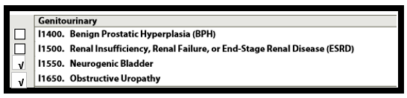

This measure may also be risk adjusted!!
Covariates adjust for individual resident characteristics or health conditions that are essentially out of the facility’s control that may contribute to worse outcomes for a particular QM.

Two coviariates are applied to this measure, which include residents with:
- Frequent bowel incontinence on prior assessment (H0400 = [2, 3]), and/or
- Pressure ulcers at stages II, III, or IV on prior assessment: (M0300B1, M0300C1, and/or M0300D1 = [1, 2, 3, 4, 5, 6, 7, 8, 9]).
On the CASPER Facility Level QM report, the Facility Adjusted Percent is the final calculation after covariate factors have been applied. This risk adjusted percentage is used to determine points for the Five Star QM Rating.
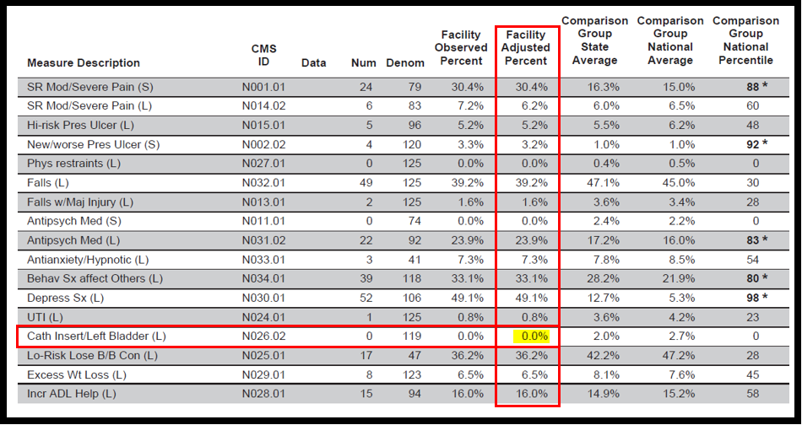
Tips for Success!
- This is a Long Stay measure, so new residents admitted with a catheter will not trigger this measure until they have been in the facility for >100 days. Work with the resident’s provider, early in the stay, to determine if the catheter is necessary or if you can attempt to remove it. If the attempt fails, consult a specialist for further interventions or proper exclusionary diagnoses.
- Review all residents with catheters who have a neurological condition (i.e. Multiple Sclerosis), cerebrovascular disease, or spinal cord injury.
  - Ask the resident’s provider if Neurogenic Bladder should be added to the resident’s diagnosis list.
- Review all residents with BPH or Prostate Cancer.
  - Ask the resident’s provider if Obstructive Uropathy should be added to the resident’s diagnosis list.
- Identify residents on your Resident Level QM report who are triggering. If their catheter has been discontinued since their last MDS or a new exclusionary diagnosis has been added to their list of conditions, consider completing a new MDS (a new Target Assessment).

