Percent of Residents with Pressure Ulcers That Are New or Worsened (Short Stay)

This measure captures the percentage of short-stay residents with new or worsening Stage II-IV pressure ulcers.

Key Points!
- The short-stay and long-stay pressure ulcer measures differ, significantly, in how they are triggered.
- This measure uses a look-back scan, meaning ALL qualifying assessments within the episode are scanned for triggering MDS items.
  - Qualifying Assessments include: Admission, Quarterly, Annual, Significant Change, Significant Correction, PPS 5-day, 14-day, 30-day, 60-day, 90-day, DRA, DRNA.

What MDS Items Trigger the Short-Stay Pressure Ulcer Measure?
- Short-stay residents will trigger when section M0800 (Worsening in Pressure Ulcer status) on ANY assessment in the look-back scan, includes any of the following condtions:
  - Stage II, M0800A is > 0, or
  - Stage III, M0800B is > 0, or
  - Stage IV, M0800C is > 0.

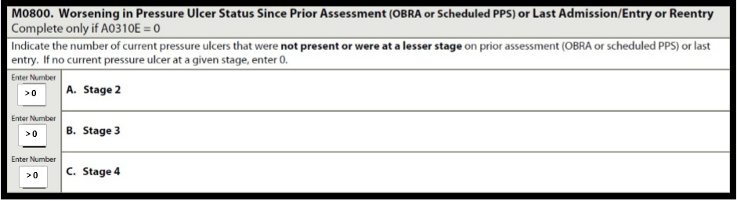

This measure may be risk adjusted!!
Covariates adjust for individual resident characteristics or health conditions that are essentially out of the facility’s control that may contribute to worse outcomes for a particular QM.

Multiple coviariates are applied to this measure, which include residents with:
- Limited or more assistance in bed mobility on the Initial Assessment (G0110A1=2, 3, 4, 7, 8)
- At least occassionally incontinent of bowel on the Initial Assessment (H0400 = [1, 2, 3])
- Diagnosis of DM or PVD coded on the Initial Assessment (I0900 PVD and/or I2900 DM is checked)
- Low Body Mass Index (BMI is 12.0-19.0), based on Height (K0200A) and Weight (K0200B) on the Initial Assessment.
Initial Assessment is the first assessment following the admission entry record. May be an Admission, PPS 5-day, DRA, or DRNA.
On the CASPER Facility Level QM report, the Facility Adjusted Percent is the final calculation after covariate factors have been applied. This risk adjusted percentage is used to determine points for the Five Star QM Rating.
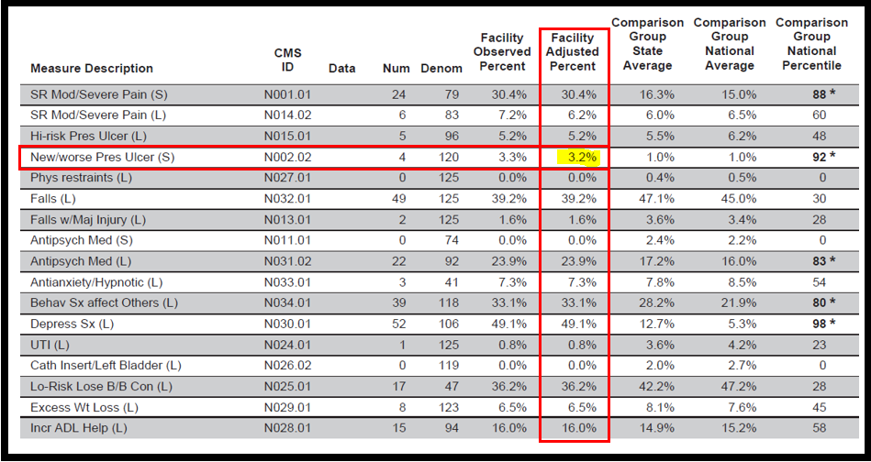
Tips for Success!
- Residents admitted with a pressure will not trigger this measure simply because they have a pressure ulcer. To trigger, the pressure ulcer must worsen in-house (when compared to its stage upon admission), or be acquired in-house.
- To accurately reflect your facility’s risk adjustment, be careful to code all applicable covariate items on each residents’ Initial Assessment (which could be a discharge).
- Educate floor nurses on proper staging immediately upon admission.
- Consider floor nurses alerting a manager if a resident has skin impairment in order to ensure accurate staging and providing one on one teaching with floor nurses at the time of admission.
- Have your MDS nurses and any wound nurses meet to discuss in detail the guidance provided in the RAI manual.
- Consider consistent assignment for pressure ulcer weekly skin assessment if more than 1 nurse is doing weekly measurements and staging of a pressure ulcer.
- Implement a competency based training on pressure ulcer documentation and staging upon new hire, yearly, and as needed.
- Only epithelial tissue can be present in a Stage II pressure ulcer. If granulation, slough, or eschar tissue is present, the Stage is III or higher.
- Review hospital documentation. A pressure ulcer should be staged at the deepest anatomical stage it has ever been. Do not reverse or back-stage.
  - i.e. Resident admits, upon assessment, a pressure area to the coccyx appears to be a Stage III (no exposed bone, tendon, or muscle). Hospital paperwork includes a wound assessment, staging the same wound at a Stage IV. This represents a healing Stage IV, and should be coded a Stage IV.
- Know how to accurately code M0800 (Worsening in Pressure Ulcer status)!!! This is one of the most common items on the MDS to be incorrectly coded.
  - Worsening is defined as a pressure ulcer that has progressed to a deeper level of tissue damage and is therefore staged at a higher number (II, III, or IV) than that numerical stage on a previous assessment. A pressure ulcer that has increased in dimensional size (Length, Width, Depth) or has other clinical indications of decline (i.e s/sx of infection), is NOT considered worsened, unless the level of tissue damage results in a higher NUMERICAL STAGING of the pressure ulcer.
  - Worsening can only be determined by comparing the current NUMERICAL STAGE (I-IV) to the NUMERICAL STAGE on previous assessments. (i.e. Stage I to II, II to III, III to IV, etc)
    - Coding worsening of unstageable pressure ulcers (RAI User’s Manual, Ch. 3, pages M26-27):
      - If a pressure ulcer was unstageable on admission/entry or reentry, do not consider it to be worsened on the first assessment that it is able to be numerically staged. However, if the pressure ulcer subsequently increases in numerical stage after that assessment, it should be considered worsened.
        - Intact skin should be carefully assessed for Suspected Deep Tissue Injury. Nurses need to be able to determine the difference between a Stage I and sDTI. An sDTI that later opens to a Stage III or IV, would not be considered worsened on the first assessment that it becomes stageable.
        - When a pressure ulcer presents as an intact blister, examine the adjacent and surrounding area for signs of deep tissue injury and if present, Stage as DTI, not Stage II.
      - If a pressure ulcer was numerically staged and becomes unstageable due to slough or eschar, do not consider this pressure ulcer as worsened. The only way to determine if this pressure ulcer has worsened is to remove enough slough or eschar so that the wound bed becomes visible. Once enough of the wound bed can be visualized and/or palpated such that the tissues can be identified and the wound restaged, the determination of worsening can be made.
      - If a pressure ulcer was numerically staged and becomes unstageable, and is subsequently debrided sufficiently to be numerically staged, compare its numerical stage before and after it was unstageable. If the pressure ulcer’s current numerical stage has increased, consider this pressure ulcer as worsened.
      - If two pressure ulcers merge, do not code as worsened. Although two merged pressure ulcers might increase the overall surface area of the ulcer, there would need to be an increase in numerical stage in order for it to be considered as worsened.
      - If a pressure ulcer is acquired during a hospital admission, its stage should be coded on admission and is considered as present on admission/entry or reentry. It is not included or coded as new or worsened, in M0800.
      - If a pressure ulcer increases in numerical stage during a hospital admission, its stage should be coded on admission and is considered as present on admission/entry or reentry. It is not included or coded in this item. While not included in this item, it is important to recognize clinically on reentry that the resident’s overall skin status deteriorated while in the hospital. In either case, if the pressure ulcer deteriorates further or increases in numerical stage on a subsequent MDS assessment, it would be considered as worsened and would be coded in this item.
- If a pressure ulcer is surgically closed with a flap or graft, it should be coded as a surgical wound and not as a pressure ulcer.
- If a resident had a pressure ulcer that healed during the look-back period of the current assessment, but there was no documented pressure ulcer on the prior assessment, M0210 (Does the resident have one or more unhealed pressure ulcers at Stage 1 or higher?) should be coded No [0].

