Percent of High-Risk Residents With Pressure Ulcers (Long Stay)

This measure captures the percentage of long-stay, high-risk residents with Stage II-IV pressure ulcers.

Key Points!
- The short-stay and long-stay pressure ulcer measures differ, significantly, in how they are triggered.
- For the Long-Stay measure, only the Target Assessment is used. The Target Assessment is the most recent assessment in the target period (i.e. a calendar quarter).
What MDS Items Trigger the Long-Stay Pressure Ulcer Measure?
- Long-stay residents will trigger this QM when their target assessment meets both conditions 1 and 2:
- Condition #1: There is a high risk for pressure ulcers where any of the following are true:
  - Bed mobility, self-performance= Extensive, Dependent, Activity Occurred only once or twice, Activity did not occurr (G0110A1 = [3, 4, 7, 8]).
  - Transfer, self-performance= Extensive, Dependent, Activity Occurred only once or twice, Activity did not occurr (G0110B1 = [3, 4, 7, 8]).
  - Comatose (B0100 = [1]).
  - Malnutrition or at risk of malnutrition (I5600 = [1]) (checked).
- Condition #2: One or more Stage II-IV pressure ulcers are present (M0300B1 = [1, 2, 3, 4, 5, 6, 7, 8, 9]) or (M0300C1 = [1, 2, 3, 4, 5, 6, 7, 8, 9]) or (M0300D1 = [1, 2, 3, 4, 5, 6, 7, 8, 9].
Condition #1: High Risk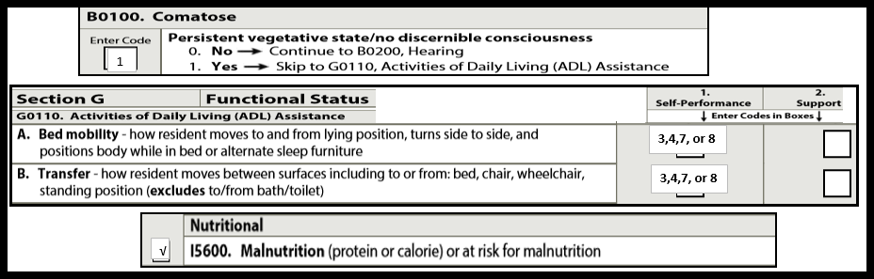
Condition #2: Stage II-IV 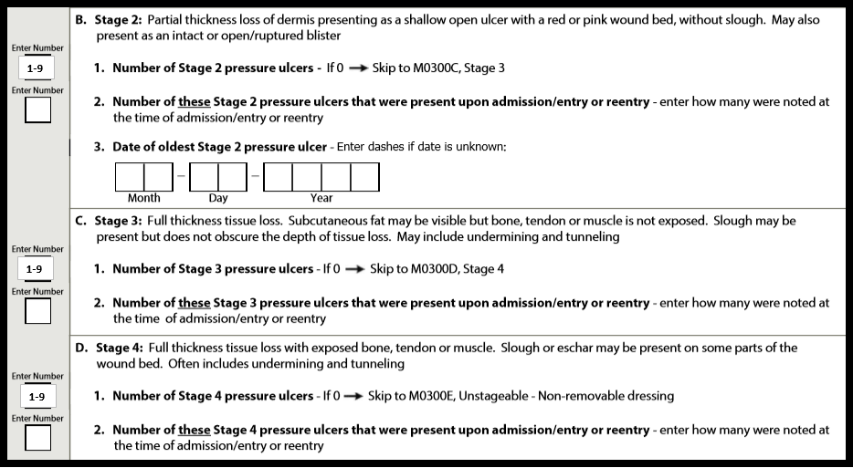
Here’s the only exclusion!!
If the target assessment is an Admission assessment (A0310A = [01]) or a PPS 5-day assessment (A0310B = [01]), it will not trigger.

Tips for Success!
- Because this is a long-stay measure, residents who have Stage II-IV pressure ulcers will not trigger until they have been in the facility for more than 100 days. This means the facility has 100 days from admission to get pressure ulcers healed. (However, keep in mind that in-house acquired pressure ulcers will trigger the short-stay measure for residents who have been in the facility less than 100 days).
- Unstageable pressure ulcers do NOT trigger this measure.
- The larger your denominator is, the lower your percentage will be.
- Only residents who are high risk (not all residents) are included in the denominator. Therefore, always ensure MDS coding is accurate to reflect comatose, extensive assist or more with bed mobility and transfers, and malnutrition on all assessments, as applicable.
- If a pressure ulcer is surgically closed with a flap or graft, it should be coded as a surgical wound and not as a pressure ulcer.
- If a resident had a pressure ulcer that healed during the look-back period of the current assessment, but there was no documented pressure ulcer on the prior assessment, M0210 (Does the resident have one or more unhealed pressure ulcers at Stage 1 or higher?) should be coded No [0].
- Only the target assessment is used. If a pressure ulcer heals and another MDS is completed, then this new target assessment would be coded as no current Stage II-IV areas.

