Percent of Residents Who Made Improvements in Function (Short Stay)

This measure reports the percentage of short-stay residents who were discharged from the nursing home that gained more independence in transfer, locomotion, and walking during their episodes of care.

Key Points!
- A HIGHER percentage indicates better performance!
- This is a new Quality Measure that was added to the QM Manual April 1, 2016. It began impacting the Five Star Rating and was first publically reported in July 2016.
- This measure is NOT displayed on the “real-time” Facility Level or Resident Level QM reports.
- This measure is included, at the facility-level, on the Preview of Quality Measure Score report and the 5star report; and at the resident-level, on the Public Reporting Resident Report. All of these reports are posted to the facility’s CASPER folder, usually about 1-2 weeks before Nursing Home Compare’s quarterly update.
- For this measure, the PPS 5-day or Admission assessment is compared to the Discharge Return NOT anticipated assessment. No other assessments are used.
What MDS Items Trigger this Measure?
- Short-stay residents will trigger this QM when their DRNA assessment compared to their PPS 5-day or Admission assessment shows improvement in transfers, walking in cooridor and/or locomotion on unit.
- Improvement is determined by adding the self-performance codes on each assessment to reach a sum (this is the Performance score). Residents will trigger when they have a change in performance score from Admission (or 5-day) to Discharge (return NOT anticipated) that is negative.
  - If any items are coded 7 (activity occurred only one or twice) or 8 (activity did not occur), these are recoded to 4 for the purpose of adding to reach the sum.
Example: On the PPS 5-day or Admission assessment, the resident is coded as follows: Transfers = 3 Extensive, Walk in Cooridor =8 activity did not occur (recoded to 4), Locomotion on unit = 3 Extensive. The total Performance Score is 10.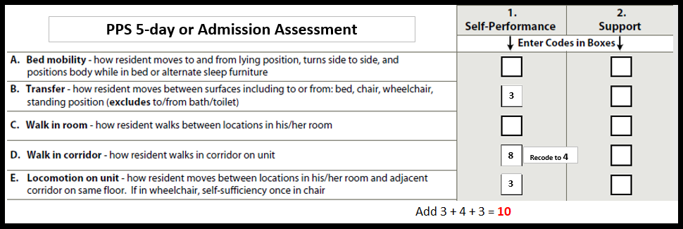Example (cont): On the DRNA assessment, the resident is coded as follows: Transfers = 3 Extensive, Walk in Cooridor = 3
Extensive, Locomotion on unit = 2 Limited. The total Performance Score is 8.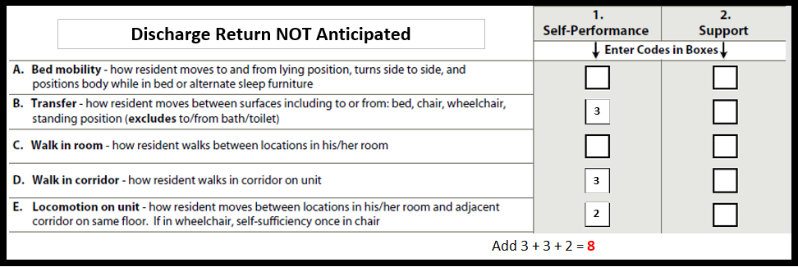
Example (cont): When comparing the DRNA(8) to the PPS 5-day or Admission(10), the change in Performance Score is -2 (8-10).
This measure has many Exclusions!!
Residents with any of the following are excluded:
- Comatose (B0100 = [1]) on the 5-day or admission assessment.
- Life expectancy of less than 6 months (J1400 = [1]) on the 5day or admission assessment.
- Hospice (O0100K2 = [1]) on the 5-day or admission assessment.
- Residents with no impairment (sum of G0110B1, G0110D1 and G0110E1 = [0]) on the 5-day or admission assessment.
- Residents with an unplanned discharge on any assessment during the care episode (A0310G = [2]).

This measure also has many Risk Adjustments!!
- All of the covariates are derived from the PPS 5-day or Admission assessment.
- Risk adjustments are made based of age, gender, cognitive impairment, long-form ADL score, heart failure, stroke, hip or other fracture. See QM Manual for details.

Tips for Success!
- Code ADLs on the PPS 5-day or Admission accurately!
  - Observe the resident and conduct staff interviews to assess and determine true self-performance. Do not rely on auto-populated responses pulled from electronic STNA documentation without validating that it is accurate.
  - Accurately capturing the MOST DEPENDENT level of self-performance will help to show improvement!
- Historically, walking in corridor and locomotion have not been a huge emphasis for MDS nurses. MDS nurses need to be aware of the impact coding these 2 mid-loss ADLs have on your facility’s Quality Measures.
- Ensure exclusions are coded on the PPS 5-day or Admission assessment, if applicable (comatose, Hospice, Prognosis <6mos).
- Know when to code the discharge as unplanned so that it will be excluded. Residents who discharge unexpectedly, especially after a very short stay, are less likely to show improvement.
  - Exclusions will make your denominator smaller, resulting in a higher percentage. (i.e 5 out 20 is 25%. Whereas, 5 out of 10 is 50%). Remember higher performance is better for this measure.

