Percent of Residents Experiencing One or More Falls with Major Injury

(Long Stay)

This measure reports the percent of long stay residents who have experienced one or more falls with major injury reported in the target period or look-back period.

Key Points!
- It is the only long stay measure that uses the look-back scan; the most recent MDS and any other qualifying MDS in the previous 275 days are scanned.

What MDS item triggers this measure?
- Long-stay residents will trigger this measure when any qualifying assessment in the look-back scan indicates one or more falls that resulted in major injury (J1900C = [1, 2]).

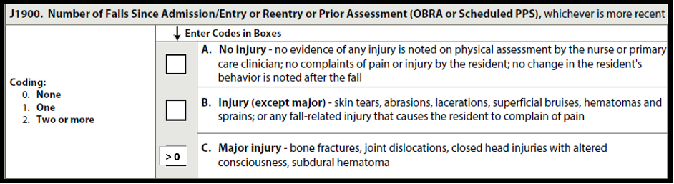

This measure has NO exclusions (except if dashed) and NO covariates!!

Tips for Success!
- Know the definition of Major Injury!! A major injury is defined in the RAI User’s Manual as:
  - bone fracture
  - joint dislocation
  - closed head injury with altered consciousness
  - subdural hematoma
- Every head injury is NOT a major injury!
- Use a tracking system. Once 275 days have passed, determine if another MDS should be completed. This would result in the resident being removed from triggering.

Example
