Percent of Residents with a Urinary Tract Infection (Long Stay)

This measure reports the percentage of long stay residents who have a urinary tract infection.

Key Points!
- Only the Target Assessment is used. The Target Assessment is the most recent assessment in the target period (i.e. a calendar quarter).

What MDS item triggers this measure?
- Long-stay residents with a selected target assessment that indicates urinary tract infection within the last 30 days (I2300 = [1].)

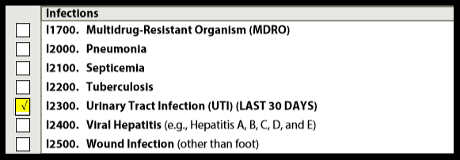

This measure has one exclusion!
If the Target assessment is an admission assessment or a PPS 5-day, it is excluded.

Tips for Success!
- Criteria changed October 1, 2017- See updated RAI User’s Manual
- — Code only if both of the following are met in the last 30 days:
  - 1. It was determined that the resident had a UTI using evidence-based criteria such as McGeer, NHSN, or Loeb in the last 30 days, AND
  - 2. A physician documented UTI diagnosis (or by a nurse practitioner, physician assistant, or clinical nurse specialist if allowable under state licensure laws) in the last 30 days.

- On a weekly basis, review residents triggering on your Resident Level Quality Measure Report. Determine if a new MDS can be completed 30 days post UTI to establish a new Target Assessment before the end of the quarter.

