Percent of Residents Who Were Physically Restrained (Long Stay)
This measure reports the percent of long stay nursing facility residents who are physically restrained on a daily basis.

Key Points!
- Only the Target Assessment is used. The Target Assessment is the most recent assessment in the target period (i.e. a calendar quarter).

What MDS item triggers this measure?
- Long-stay residents will trigger this measure when his/her target assessment indicates daily physical restraint use, where:
  - 1. Trunk restraint used in bed (P0100B = [2]), or
  - 2. Limb restraint used in bed (P0100C = [2]), or
  - 3. Trunk restraint used in chair or out of bed (P0100E = [2]), or
  - 4. Limb restraint used in chair or out of bed (P0100F = [2]), or
  - 5. Chair prevents rising used in chair or out of bed (P0100G) = [2]).
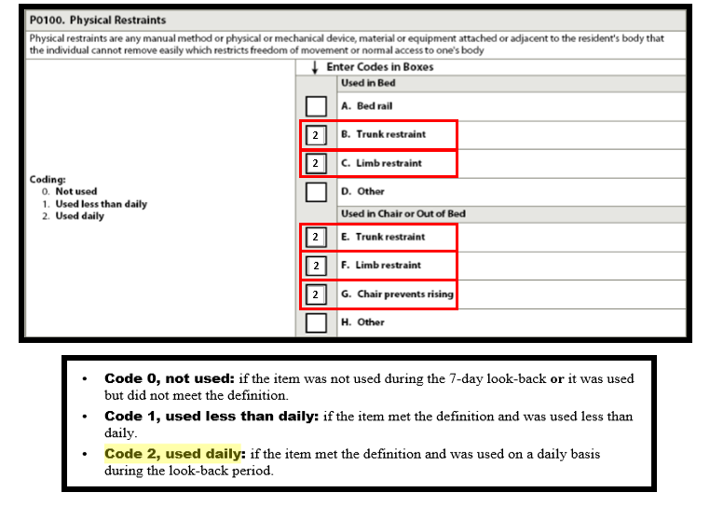

This measure has NO exclusions and NO risk-adjustments!

Tips for Success!
- To determine if a device is a restraint, the assessor must consider the impact the device has on the resident, rather than the device itself. A device may be a restraint for one resident, but not a restraint for another resident. Only code a device as a restraint when it meets the definition, which is:
  - Any manual method or physical or mechanical device, material or equipment attached or adjacent to the resident’s body that the individual cannot remove easily, which restricts freedom of movement or normal access to one’s body.
    - If the device is not restricting the resident from mobility s/he could demonstrate without the device in place, then it should not be classified as a restraint.
- Bed rails, “other” restraints used in bed, and “other” restraints used out of bed do NOT trigger this measure.
- Only Daily Use of restraints will trigger. Restraints used less than daily, will NOT trigger.
  - Consider your restraint reduction program. If attempting a restraint reduction where the resident will be restraint-free for at least one day, schedule your MDS to include the restraint-free day in the 7 day look-back period. In this case, the restraint would be coded 1, used less than daily.
- If a restraint has been discontinued or used less than daily, consider completing a new Target assessment before the end of the quarter.

Changes to Section P, effective October 1, 2017:

- Section P will be titled RESTRAINTS AND ALARMS

Although alarms have been added to section P, CMS has not proposed any change to the restraint Quality Measure, so alarms will not trigger the measure at this time.

