Percent of Residents Whose Ability to Move Independently Worsened (Long Stay)

This measure reports the percent of long stay residents who experienced a decline in independence of locomotion during the target period.

Key Points!
- This is a new Quality Measure that was added to the QM Manual April 1, 2016. It began impacting the Five Star Rating and was first publically reported in July 2016.
- This measure is NOT displayed on the “real-time” Facility Level or Resident Level QM reports.
- It is included, at the facility-level, on the Preview of Quality Measure Score report and the 5star report; and at the resident-level, on the Public Reporting Resident Report. All of these reports are posted to the facility’s CASPER folder, usually about 1-2 weeks before Nursing Home Compare’s quarterly update.
- For this measure, the Target assessment is compared to a Prior assessment.
  - Target Assessment is the most recent assessment in the target period (i.e. a calendar quarter).
  - Prior Assessment is the latest assessment that is 46 to 165 days before the target assessment.
What MDS Item Triggers this Measure?
- Long-stay residents will trigger this QM when their Target assessment compared to their Prior assessment shows a 1 or more point decline in locomotion on unit self performance (G0110E1).
  - Recoding all values of [7 or 8] to [4].

Example: On Prior assessment, the resident is coded as follows: Locomotion on unit = 3 Extensive. 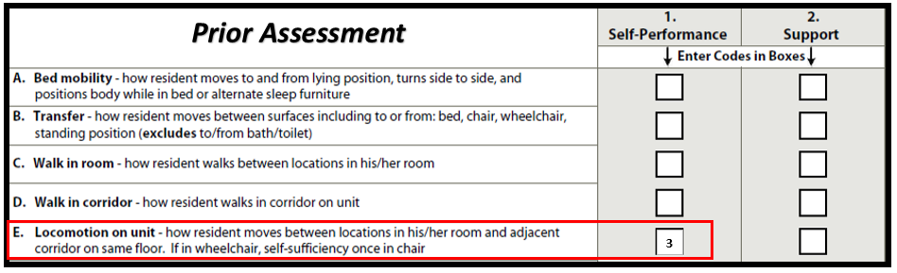
Example (cont): On the Target assessment, Locomotion on unit = 4 Dependent. 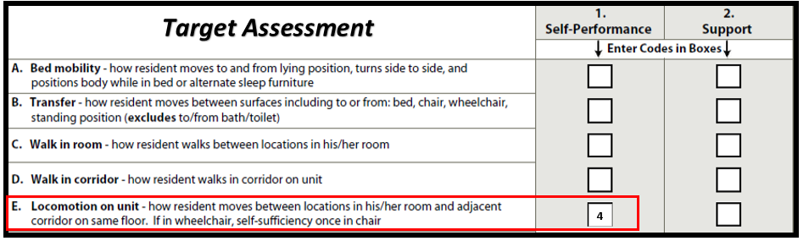Example (cont): When comparing the Target Assessment (4) to the Prior Assessment (3), Self-Performance shows a decline in independence by 1 or more points.
This measure has many Exclusions!!
Residents with any of the following are excluded:
- Comatose (B0100 = [1]) on the Prior assessment.
- Life expectancy of less than 6 months (J1400 = [1]) on the Prior assessment.
- Hospice (O0100K2 = [1]) on the Prior assessment.
- Resident was totally dependent (or did not occur / only occurred once or twice) during locomotion on prior assessment (G0110E1 = [4, 7, or 8]).
- Prior assessment is a DRA or DRNA.
- No prior assessment is available.

This measure also has a few Risk Adjustments!!
- All of the covariates are derived from the Prior assessment, and are based on:
  - Self-Performance with eating, toileting, transfer, and walking in corridor.

Tips for Success!
- Code ADLs accurately!
  - Observe the resident and conduct staff interviews to assess and determine true self-performance. Do not rely on auto-populated responses pulled from electronic STNA documentation without validating that it is accurate.
  - Accurately capturing the MOST DEPENDENT level of self-performance on the prior assessment is key!
  - The updated version of the RAI Manual, effective October 1, 2017, adds important clarifications and an updated ADL algorithm related to the Rule of 3.
- Historically, locomotion has not been a huge emphasis for MDS nurses, but they need to be aware of the impact inaccurately coding this item may have on your facility’s Quality Measures.
- Ensure exclusions are coded on the Prior assessment, if applicable (comatose, Hospice, Prognosis <6mos).
- Have a system in place for therapy to screen residents well before they are due for an MDS. If decline is noted, implement interventions to facilitate attaining prior level of self-performance before the observation window opens.
- Most software systems will alert the MDS nurse when a decline has occurred or are capable of providing this information in a report. Identify these residents. Check accuracy.
  - If decline is true:
    - Implement interventions to attain prior level or avoid further decline, as practicable.
    - Schedule a new target assessment at least 46 out from the MDS that first noted the decline. Then the new target assessment compared to the MDS that showed decline will be the same or show improvement (rather than 1 or more points of decline).

Consider this Example using Quarter 2 2017, period ending 6/30/17:
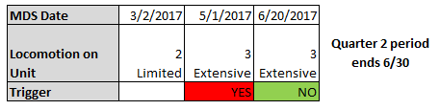
    - 5/1/17 creates the Target Assessment for Q2 and when compared to the Prior Assessment 3/2/17, a decline in locomotion is triggered.
    - If 5/1 stands as the Target Assessment for Q2 2017, this resident would trigger for decline.
    - However, if a new Target Assessment is established on 6/20/17, when comparing it to 5/1/17 (because 5/1 becomes new Prior Assessment/46+ days back), a decline is NOT triggered for Q2.

