Percent of Residents Whose Need for Help with Activities of Daily Living Has Increased (Long Stay)

This measure reports the percent of long-stay residents whose need for help with late-loss Activities of Daily Living (ADLs) has increased when compared to the prior assessment.

Key Points!
- For this measure, the Target assessment is compared to a Prior assessment.
  - Target Assessment is the most recent assessment in the target period (i.e. a calendar quarter).
  - Prior Assessment is the latest assessment that is 46 to 165 days before the target assessment.
What MDS Item Triggers this Measure?
- Long-stay residents will trigger this QM when their Target assessment compared to their Prior assessment shows an increase in self-performance with the 4 late-loss ADLs (bed mobility, transfers, eating, toileting). An increase is defined as either:
  - Two or more coding points in one ADL, or
  - One coding point in two ADLs.
(Recoding all values of [7 or 8] to [4])

Example 1: On Prior assessment, the resident is coded as follows: Eating = 2 Limited; On the Target assessment Eating = 4 Dependent. (increase by two coding points in one late loss ADL)
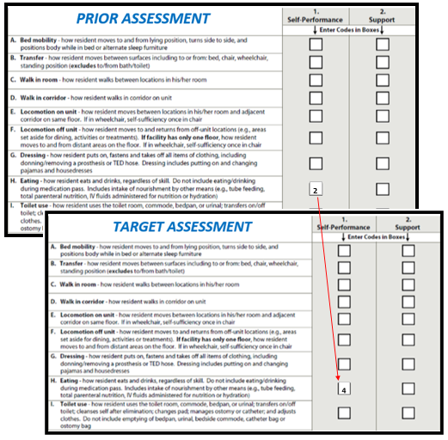
Example 2: On Prior assessment, the resident is coded as follows: Bed Mobility = 2 Limited; Transfers = 2 Limited. On the Target assessment Bed Mobility = 3 Extensive; Transfers = 3 Extensive. (increase by one coding point in two late loss ADLs)
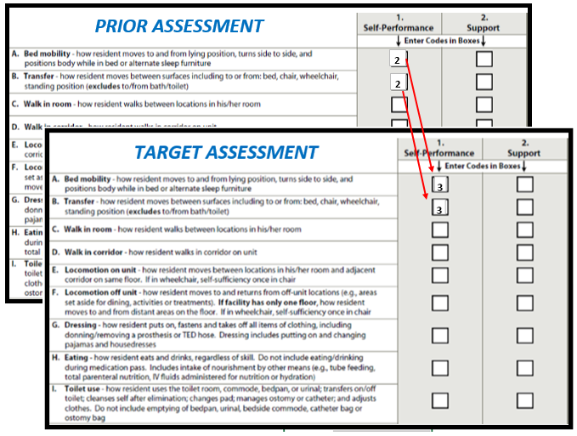

This measure has a few Exclusions!!
Residents with any of the following are excluded:
- Comatose (B0100 = [1]) on the Target assessment.
- Life expectancy of less than 6 months (J1400 = [1]) on the Target assessment.
- Hospice (O0100K2 = [1]) on the Target assessment.

This measure has NO Risk Adjustments!!

Tips for Success!
- Code ADLs accurately!
  - Observe the resident and conduct staff interviews to assess and determine true self-performance. Do not rely on auto-populated responses pulled from electronic STNA documentation without validating that it is accurate.
  - Accurately capturing the MOST DEPENDENT level of self-performance on the prior assessment is key!
  - The updated version of the RAI Manual, effective October 1, 2017, adds important clarifications and an updated ADL algorithm related to the Rule of 3.
- Keep in mind only self-performance for the late-loss ADLs are considered. Staff support (in column 2 of section G) is not used to in this measure.
- Ensure exclusions are coded on the Target assessment, if applicable (comatose, Hospice, Prognosis <6mos).
- Have a system in place for therapy to screen residents well before they are due for an MDS. If decline is noted, implement interventions to facilitate attaining prior level of self-performance before the observation window opens.
- Most software systems will alert the MDS nurse when a decline has occurred or are capable of providing this information in a report. Identify these residents. Check accuracy.
  - If decline is true:
    - Implement interventions to attain prior level or avoid further decline, as practicable.
    - Schedule a new target assessment at least 46 days out from the MDS that first noted the decline. Then the new target assessment compared to the MDS that showed increased coding points will have the same or fewer coding points.

Consider this Example using Quarter 2 2017, period ending 6/30/17:
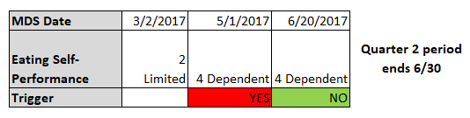
    - 5/1/17 creates the Target Assessment for Q2 and when compared to the Prior Assessment 3/2/17, an increase in 2 coding points for one late-loss ADL triggers the measure.
    - If 5/1 stands as the Target Assessment for Q2 2017, this resident would trigger for increased help with ADLs.
    - However, if a new Target Assessment is established on 6/20/17, when comparing it to 5/1/17 (because 5/1 becomes new Prior Assessment/46+ days back), an increase in help with ADLs is NOT triggered for Q2.
      - **This will only work if the assessments being compared are at least 46 days apart.

