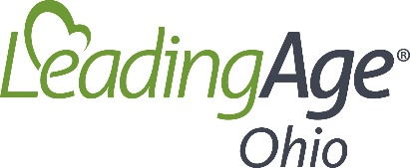
2021 Board Dates
Board meeting*: February 11 (Thursday)
LeadingAge Leadership Summit:
April 19 – 21 Cancelled
Board meeting*: May 13 (Thursday)
Leadership Summit: September 28
Board meeting*: August 12 (Thursday)
LeadingAge Ohio Annual Conference:
August 4 - 6, Columbus
LeadingAge Annual Conference:
October 24 - 27, Atlanta
Board meeting*: November 11 (Thursday)
*Board meeting time:
10 am – 2 pm

